From Your Entrepreneur & Small Business Committee:
Here are notes from Sharing Your Story (March ESB Event) Presentation:

You may find them a useful stand-alone tool for shorter or longer introductions and writing biographies. This was also meant as a helpful lead-in for our upcoming April and May programs.

We would love to have you join us for the next step programs scheduled for April (Pitch Like a Pro) and May (Claim Your Genius – Find & Use Your Business Superpowers to Stand Up and Move Up.

This is a short quick personal introduction. This is what you would be working towards in this session. With just a few word tweaks, this can be used in many ways.
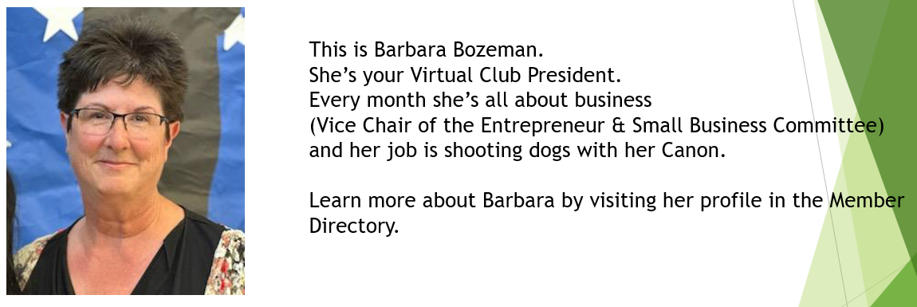
Imagine here – this would or could be a way to introduce someone. Transition the words to the “I” form and it is a quick introduction to yourself.
*the “Learn more” phrase was for the website and magazine use.

Context is key!
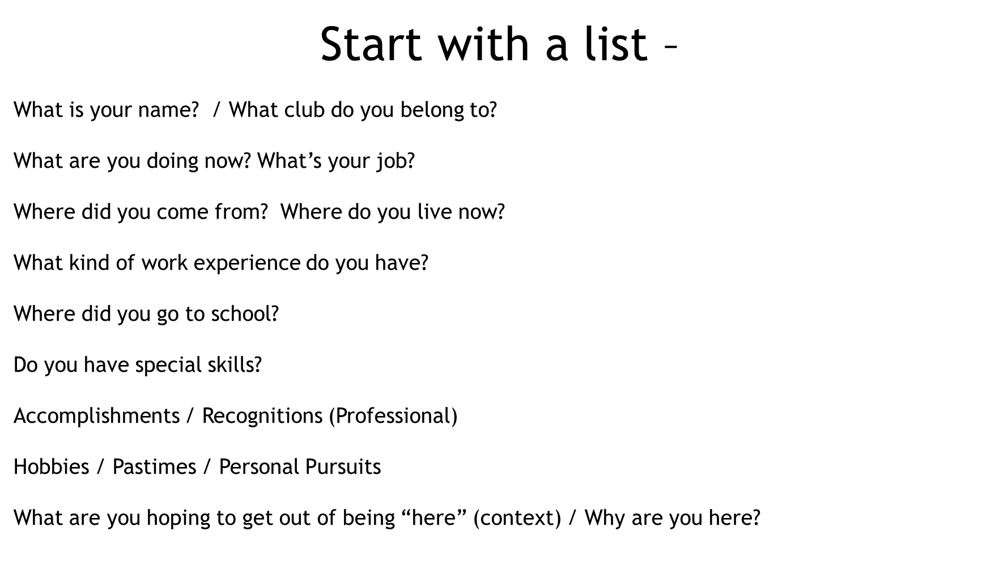
This is not an all-inclusive list; you can go on with as much as you would like – but it is just a brainstorming list – not the end product.

More to consider: (these are great for networking events)
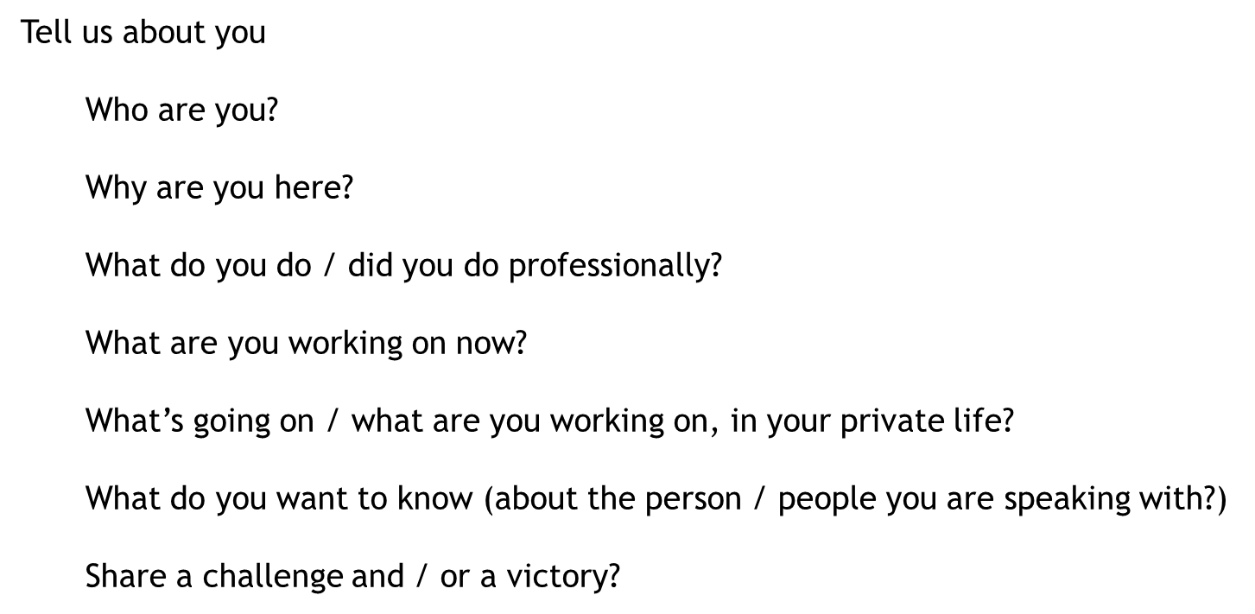

Next:
Use the bullet lists you created to come up with a few engaging sentences that would inspire someone to continue the conversation or seek you out
Leave room for flexibility (context)
You aren’t telling your life story – just creating an introduction.
In this exercise, we limited ourselves to 3-4 sentences
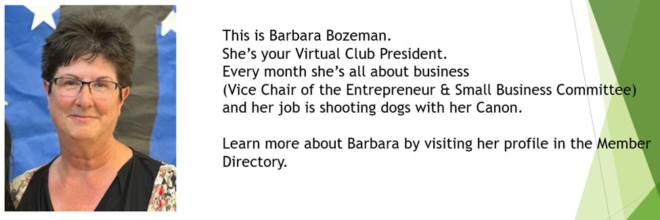

(And of course – we would love for you to use what you’ve gleaned to enhance the biography and business/organization information in your part of the member directory)
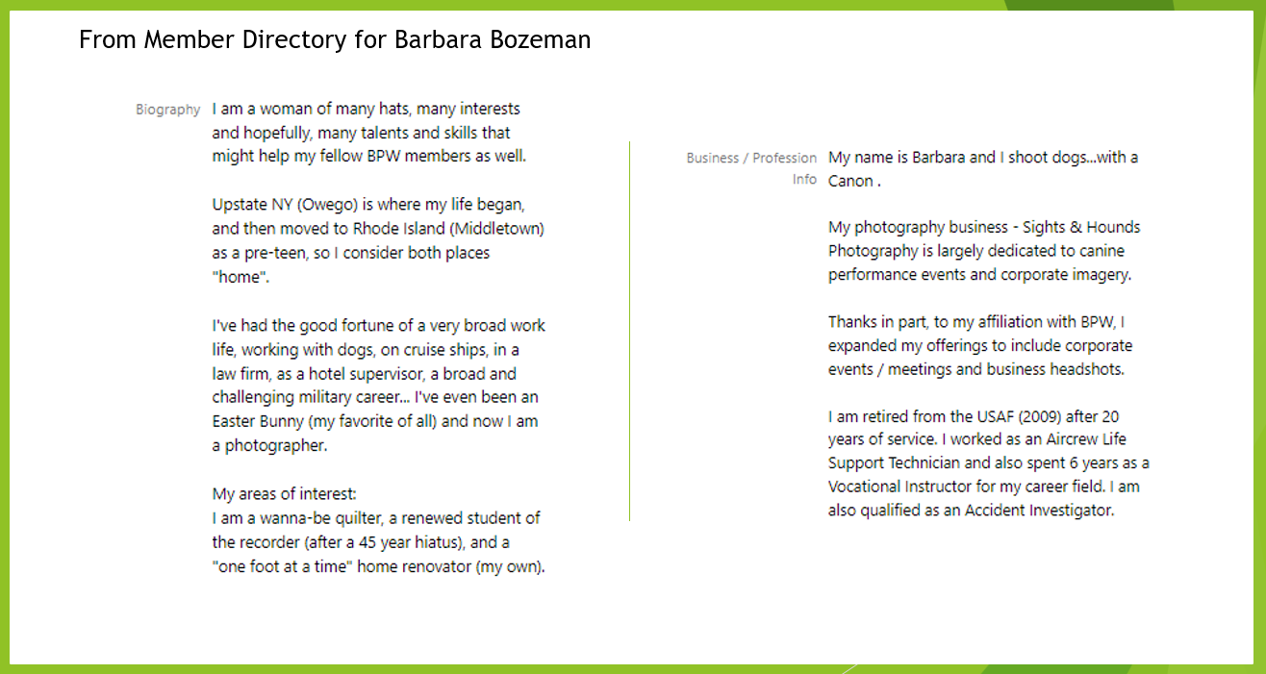

If you would like to send your photo and 3-4 sentences to us, we will be happy to provide feedback and include your finished product in upcoming magazine content as well as on our webpage and Facebook page.

Email a photo and your three sentences to:
smallbusiness@nfbpwc.org
*Please put “Share Your Story” in the Subject line of your email.

Best Regards
Marsha Riibner-Cady
Barbara Bozeman
Entrepreneur & Small Business Committee

